Flexible Enterprise Development Fund
Support for Rural Enterprise Hub

Guidance Notes for Applicants

- Background
North East Rural Growth Network (NE RGN) is a pilot initiative aims to support small business growth across rural communities in Durham, Gateshead and Northumberland. Part of the NE RGN programme is to support the development and creation of Rural Enterprise Hubs, where businesses will be offered flexible spaces with shared services; opportunities for networking and access to RGN business support services.

Newcastle University ‘Centre for Rural Economy’ (CRE) have been engaged to help the RGN Partnership understand the role of enterprise hubs in rural areas and to inform, not only the RGN Programme, but future rural policies and programmes. Following recent research by CRE into Enterprise Hubs, two additional forms of support have been introduced to help enterprise hubs to become established or for existing hubs to become more sustainable or to expand. The funding will come from Flexible Enterprise Development Fund (FEDF), a flexible pot of RGN funding administrated by Durham County Council. The fund is currently open to eligible projects until 30th September 2014 or until the available budget is fully committed.

- Who Can Apply
Enterprise Hub is defined as “the central point in a business network”, where in addition to providing physical space; additional benefits are offered e.g. shared services, business support and networking opportunities.

The grant may support private sector, including social enterprise led enterprise hubs:
- That bid unsuccessfully into the RGN enterprise hub development commissioning exercise in the Autumn of 2013 to help further strengthen project plans
- Any other enterprise hub project that is not already in receipt of RGN grant aid and is either an acknowledged enterprise hub or has the potential and aspiration to meet the above hub definition.

Public sector organisations are not eligible under this scheme. Consideration can be given via a direct application to RGN Programme Team (Ray Browning, North East Rural Growth Network Manager 01670 623952).

- Support available and eligible project costs
Two forms of support are available under FEDF - Feasibility / Development Study or Market Development Action Plan Implementation.

3.1 Feasibility / Development Study
The objectives of this scheme are as follows:
- To support the growth in the range of enterprise hubs across the rural North East where there is potential to attract new economic activity, develop local business communities / networks and add value to the local economy (hub projects that may compete with and displace activity from existing hubs are not encouraged).
- To enable existing hubs to undertake investigations into the expansion of facilities e.g. adding to existing buildings, conversion of under-used existing space or potentially adding to the offer by providing appropriate ‘move –on’ space in the vicinity.
- To create a pipeline of well-developed and researched projects that can be supported either through the current programme or future regional economic growth programmes.

Potential costs to be explored and partially met through grant support include
- Architect and Q.S. costs
- Site / building and other environmental surveys
- Valuations
- Planning fees
- Market research
- Project business plan development.

3.2 Market Development Action Plan implementation
The objectives of this scheme are to:
- Help hubs with high void levels and / or marginal financial sustainability to improve their performance.
- Assist, where appropriate, hubs to re-position their offer to attract new users/ market segments.

Marketing support, whether provided by FEDF or other external support, should reflect the provisions of a clear market development action plan, which needs to identify areas which are additional to what is currently being delivered through the hub and may include such areas as:
- Brand development
- Introduction of new events/activities which would increase participation in the hub and footfall
- Time limited marketing campaign using media not previously used
- Appointment of an agent to proactively promote the hub facility
- Minor building adaptations/equipment where this is essential to cater for new markets

- How much grant is available
Both schemes are discretionary and operate with ‘normal maximum grant levels’. They are revenue in nature but small capital costs are not ruled out if integral to the project e.g. signage / minor re-fitting to adjust to meet new markets. Grant is available up to 75% of eligible costs ranging from a minimum of £3,000 up to a maximum of £7,500.

This funding is provided under what is called the ‘de minimis’ state aid exemption. The amount of funding that any business can receive from public sources under the de minimis rules, over any three year period, is restricted to €200,000, circa £150,000. Applicants must declare how much public sector grant aid they may have received under the de minimis funding regulations in the three years up to the application. You must provide details of all grants and funded assistance that your organisation has received in the last three years where the funding/awarding body has advised that the grant approved was given as de-minimis aid.

5. What other eligibility considerations do I need to consider?

To be successful projects must meet the following requirements. You must be an existing small enterprise (less than 50 employees, with an annual turnover up to 10 million euros and a balance sheet up to 2 million euros, including social enterprises).

  - The business must be located within eligible ‘rural postcode areas’ within the RGN-NE area. The RGN Programme covers large parts of rural County Durham, Northumberland and rural areas of Gateshead. Applicants are particularly welcome from eligible businesses in more remote uplands areas and those looking to establish in local ‘hub’ developments. Please refer to the Map in Appendix 1, which outlines the RGN area. Where the post code of a business falls outside of the eligible list, then, provided it can be demonstrated that the investment made would significantly benefit an eligible area, applications may be submitted for consideration.

  - The business must be sustainable after funding has been granted. Any wider business and/or community benefits for example through collaboration or sharing of best practice / commitment to local recruitment / supply chain opportunities / providing a local service should be identified.

  - Ensure similar activities or businesses in the local area are not displaced as a result of this project being grant funded.

  - Have a secure funding package in place. This means that any additional funds (not including the FEDF grant) you require in order to complete your project need to have already been secured. This could be from your own funds, or by means of a bank loan or overdraft. Copy documentation, in the form of bank statements or copy correspondence from your lender will need to be submitted with your application form.

  - Be financially complete by 31st December 2014. This means that all costs must be paid for and have also cleared your bank account by the 31 December 2014. If any costs have not cleared your bank account by 31 December 2014, they will be become ineligible and you will be unable to claim against them.

6. How do I make an application?

In the first instance you should contact your local Rural Economic Development Officer (REDO) by phone or email with an outline of your proposed project. They will make an assessment of your project prior to submitting an application to Durham County Council’s Funding and Programmes Team.

The full application process is illustrated in Appendix 2. We hope to minimise the time it takes from receiving your application to the issue of a final decision. Our target timescale is five weeks. Whether this is achieved will often be dependent on receiving all the supporting information in good time to allow the full appraisal and assessment, to be undertaken without delay.

6.1 Application Form

Once assessed by the REDO, the completed application form will normally be appraised, approved and the decision communicated in writing within 5 weeks.

Full acceptance of the offer will only be acknowledged through return of a signed grant offer letter. The timescale for accepting the grant offer is ten working days. Projects should commence within three months from the date on the grant offer letter; if the timescale should expire, the grant offer will automatically become void and you will be notified that a new application would need to be submitted.

6.2 Outputs
Direct economic outputs from feasibility/development studies will often be limited at this stage of the project and most of the outputs below will not be applicable. The following is not exhaustive and you may wish to add other output measures to help us assess the full benefits of your project. Examples of other outputs are listed under 6.2.4.

6.2.1 New jobs created (number of jobs), this could be jobs created in business attracted
Must be new, permanent, paid, full time equivalent (FTE).
Must be a direct result of the intervention.
Must not have existed in NE RGN pilot area or with that employer in the UK before the intervention
Must have a life expectancy of at least 1 year from the point at which it is created.
FTE = paid work of 30 hours per more per week. Part time jobs can be converted to FTE either on a pro rata basis on hours worked or by 2 part time jobs = 1 FTE.
Counted when the post is filled
Evidence – copies of employment contract

    - Businesses with Improved Performance this may include:
Efficacy in conversion of inputs to outputs;
Turnover;
Production Costs;
Profitability;
Sales Levels.
The baseline(s) to be used will be agreed as part of the development of the project and the technical appraisal, on a project by project basis

6.2.3 Businesses Created
Will the FEDF grant facilitate a new business to be created? Outputs are counted when a new business starts trading in the region, or opened its premises in the region. A business starts trading when it registers for VAT or NI (Class 2) contributions, or when the first transaction is made.
Evidence required – Name, address and contact details of business. Ownership details, number of employees and type of business.
New business – the company incorporation statement or letter from the Owner/Chief Executive or Finance Director to confirm it is a new company.

    - Businesses supported to go into a network
A “network” is defined as a formal or informal grouping of inter-regional bodies sharing common aims/target groups/ambitions and active in a particular field, discipline or sector. Only one output can be counted for each given organisation or business joining the network.

6.2.4 Other output measures can be used to demonstrate differences / changes the project might deliver, for example new / upgraded floorspace (sqm), number of new business units created, a completed business plan or reduction of void levels. We will review this information on a project by project basis.

6.3 Appeals Procedure

Rejection at any stage in the approvals process can be appealed in writing. Written appeals must be received within two weeks of the initial rejection and addressed to: Claire Williams,
Funding & Programmes Manager, County Hall, Durham DH1 5UQ

The written appeal must include reasons for the appeal, additional justification and a rationale for why the panel or initial rejection should be reconsidered.

Appeals can only be made where the applicant has evidence that:

- The process has not been followed
- All the information made available in the applicants submission has not been considered
- The applicant has been disadvantaged in some way

The appeals panel will offer a fair, impartial and democratic second hearing to any rejected application; panel members will be required to cast a vote to further reject the application or overturn the rejection on the basis of submitted evidence. The majority vote will decide and in the event of a hung vote the appeal chair will have the deciding vote. A written response will be sent within 5 working days of this panel; the decision of the Appeals Panel will be final.

6.4 Monitoring Project Performance

Once a project is approved the REDO will maintain contact with you to discuss any issues that you may have at that stage and to ensure that the project is delivered successfully.

Grant is payable in respect of the gross costs incurred but, where a business is registered for VAT and VAT is recoverable, grant will be paid on the net costs only.

Approved projects are required to submit grant/expenditure claims in arrears. We will send you these claims for completion when the grant is approved and throughout the projects lifetime. You will be required to report on projects performance within the period, outputs achieved, expenditure and any issues affecting delivery. We will require certified copy of invoices and valuation certificates, if appropriate with grant claims, cheques numbers and bank statements verifying defrayal. At the final claim 10% of the grant will be retained until the project has been completed to satisfaction.

There may be other intermittent requests for monitoring information. In addition the applicant could receive requests for information by third parties (Defra and RPA) who may also undertake audit and verification visits.

7. What else do you need to consider?

7.1 Grant can only be claimed for costs incurred after you are notified of the project approval. Any costs, expenditure or works committed prior to approval are ineligible and the entire project could be at risk of losing financial support.

7.2 Procurement

There must be a regard for the need for economy and value for money for all expenditure in relation to the project. Therefore, all project purchases in respect of goods, services or works must comply with relevant procurement guidance. All goods and services must be openly and fairly procured.

The following table provides guidance on the procurement process to be used and contract value thresholds:

Contract Value | Contract Type | Procurement Process
Up to £10,000 | Services, Supplies, Works | Value for money to be demonstrated and recorded i.e. minimum of two written quotations, internet cost comparisons or catalogue listings.
£10,000 up to £50,000 | Services, Supplies, Works | 3 written quotations are to be obtained and recorded in writing

Where contract values are disaggregated each work element must adhere to the procurement rules. When a contractor is chosen they must be retained for the period and for works quoted, unless alternative quotes are sought and submitted at the time of application this contractor will be responsible for the provision of works, subcontractors and materials and to invoice for these works.

A typical example of bad practice is when contractor quotes are sought and grant offers issued on the basis of these costs and works. The applicant has then purchased materials from alternative suppliers and arranged sub contractors outside of the scope of the original quotes; this then becomes non compliant with procurement regulations and must be avoided.

Award of tender – value for money
Contracts should be awarded to the tender which provides the best overall value for money. This may be, but not need be, the lowest tender. There must be good reasons for not accepting the lowest tender. A clear, written explanation which provides justification for not accepting the lowest tender must be provided by the project application and agreed by the accountable body prior to award of contract.

Single tender action
Single tender action (ie only seeking a price from a single person or body) may be justified in exceptional circumstances, for example where there is a sole supplier with a unique service or product. The project applicant must agree this course of action with the accountable body prior to making any financial commitment or agreement to contract. Where a single tender is used, the project applicant must keep a formal written record of its justification, and evidence that it has been formally authorised.

7.3 A full audit trail as to how procurement decisions have been reached and contracts awarded must be maintained.

7.4 Deposits on purchases are not eligible until the balancing payment has been made. Hire Purchase arrangements are not supportable.

7.5 The building asset or equipment and its specified use should be retained for a period of 5 years from the date of financial completion. Any proposed sale, change of use or change of location outside the RGN area within this time must be communicated to Durham County Council in writing. A change of use to an ineligible activity or excess profit resulting from the sale of the assets could result in clawback of grant.

7.6 Applicants can be owner-occupiers, owners proposing to lease out the premises for micro business use, or tenants who have a fixed term lease with an un-expired term of at least five years.

8. Publicity and Promotion

You must ensure, as a condition of grant, appropriate acknowledgement of RGN funding by publicising the support which you have received and displaying provide logos for RGN and Defra on all marketing materials and acknowledgments in press releases.

9. Clawback

Failure to adhere to any grant offer conditions, or if noncompliance is identified during project monitoring or audit visits, could result in financial penalties and clawback of any grant paid. The regulations governing clawback will be specified in the grant offer letter. Durham County Council will manage and report on any irregularities of forecast performance and any audit issues to Northumberland County Council and Defra.

10. Freedom of Information statement:

To meet our obligations under the Data Protection Act 1998 we need to explain how we will handle the information you give us.

Because the grant will involve expenditure of public money, there is a public interest in how the money is spent. DEFRA may, in certain circumstances, make information about your application and agreement publicly available for this purpose. It will also publish an annual list of all receiving financial support under the programme, which will be available on a Government website.

We may also need to disclose details about your application and agreement to other organisations or individuals for administration, evaluation or monitoring purposes. Such information may be released upon request under the Environmental Information Regulations 2004 or the Freedom of Information Act 2000.

Details disclosed may include your name, the name of your farm or business, location, details of the project under the agreement, the grant you receive from us, any publicity you receive and details of any special environmental, design or building features.

We will request sight of the diagnostic or other report prepared by REDO to support the appraisal of the project and by signing the application form you permit this right.

Disclaimer
The information and guidance provided in this document is considered to be correct at the time of printing/publication, but is subject to change without notice. Changes in circumstances after time of publication may impact on the accuracy of this information. Please contact Durham County Council for the latest version of this guidance information.

11. Contact
We hope that the information we have supplied will assist you in completing your application for the Flexible Enterprise Development Fund grant; however, if you have any further queries, please contact us at:

Funding and Programmes Team
Room 4/43
Durham County Council
County Hall
Durham
DH1 5UQ

Team Leader – Catherine Pearson Telephone Number 03000 261893
FEDF Co-ordinator – Claire Daly Telephone Number 03000 261896
Technical Appraisals – Xiaoling Lei Telephone Number 03000 261899
Claim Queries – Julie Walkers Telephone Number 03000 266117

Appendix 1

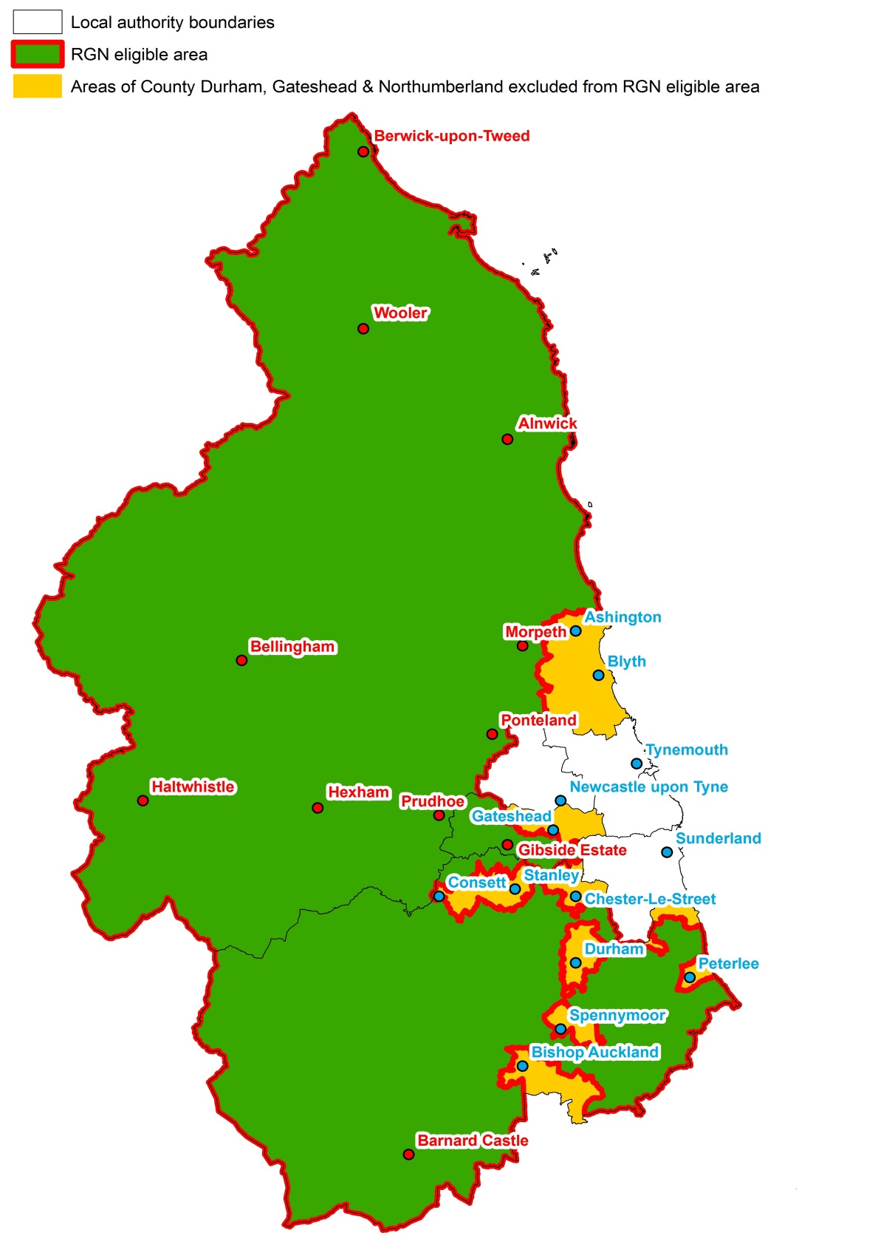

RGN Eligible Area
Non Eligible Area

Appendix 2
Where applicable, REDO to consider whether NEEAL brokered support is required to prepare Market Development Implementation Plan or initial feasibility study requirements prior to FEDF application.
Application Procedure:
Contact REDO
(Informal discussion on project ‘fit’ with guidelines. Invite to complete application.)
Application form complete and assessed by REDO against eligibility criteria
Recommendation ‘in principle’
Passed for approval
Project under £5,000
Approval by DCC Funding Team
Rejection – Notification with reasons in writing
Rejection – Notification with reasons in writing

Project between £5,001 and £15,000
Approval by Delivery Group

Grant letter offer

Monitoring through delivery period/ interim grant claims

Target 5 week approval timescale for robust applications with all supporting information submitted with application

Final claim validation and payment of 10% grant retention

Project Closure

